Documentation of Global Transportation Modeling
Page Kyle and Son Kim
May 11, 2009
Updated June 22, 2009

Background
A global transportation module to MiniCAM has been developed. The aim was to disaggregate the transportation sector in each region into passenger and freight services, and represent all technologies as MiniCAM tranTechnologies (with explicit services, and tracking of speed and passenger time in transit). The project is quite data-intensive, and this first cut is mostly directed at getting together a representation capable of producing reasonable output that future users/developers can improve as needed. In the present version, technology efficiencies, non-energy costs, load factors, and transit speeds are assumed equal for all regions, and equal to the values assumed in the detailed U.S. transportation module.
The existing core model representation for global regions is shown in Figure 1, for comparison with the new structure. Three services are disaggregated. The representation of the U.S. transportation sector in the new module is intended to replace the detailed U.S. module that has been in use for the last several years; it differs in several ways (detailed below). The structure is somewhat different, designed to improve on several weaknesses of the current U.S. module. As there is no advantage to maintaining two different transportation sector structures (one for the U.S. and the other for the rest of the world), the detailed U.S. input set used in the past several years will no longer be maintained.
First off, the light truck and auto categories have been merged into a single light-duty vehicle category. There are several reasons for this merge. For one, this makes a more consistent representation to use in non-US regions, as light trucks for passenger transport are less common outside of the US. The practical disaggregation of light duty vehicles in India, for instance, would be between cars and two-wheelers. Secondly, the split between light truck and auto in the U.S. did not consist of actually different transit “modes”; these represent different vehicle choices within a mode. Modal choice is driven primarily by average transit speeds in the context of changing income. However it is irrelevant for the auto/truck choice.
Secondly, road is now considered a “mode,” and buses and LDV’s compete within this mode. This required making a new supplysector with competing tranSubsectors. The decision to nest bus and LDV one level below the passenger tranSubsectors basically reflects that buses and LDV’s are more substitutable for one another than the other modes. They may therefore be assigned a different logit exponent.
The third difference between the new detailed transportation sector and the US detailed transportation sector is that international shipping is no longer considered a competing mode of freight transport. It is its own final demand now. This reflects that the other modes of transport are domestic, and shouldn’t be competing with international shipping to provide freight services, as these are fundamentally different types of freight service.
Several other minor differences from the detailed US representation bear mention. Pipeline energy use is now accounted in natural gas transformation sectors in the model, rather than as a final demand. Military fuel use and recreational offroad transportation are not broken out. Military fuel use in the IEA database is in “other sectors” and is mapped to buildings in MiniCAM. I’d guess recreational offroad energy is either under domestic ship or road, but it isn’t explicitly broken out. This doesn’t matter as these aren’t categories that we need to be modeling anyway; we just need for the energy to be accounted, and it is.

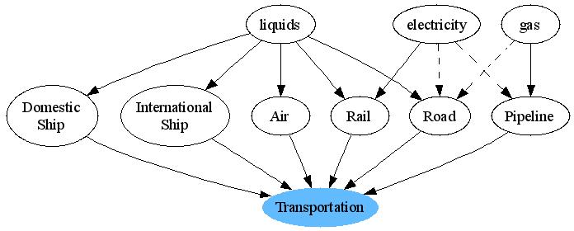

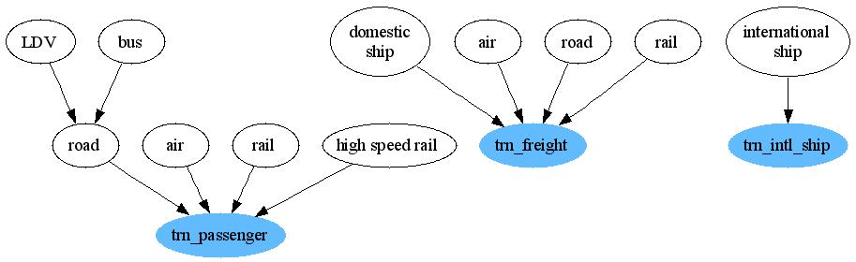
Figure 1. Aggregate (above) and detailed (below) transportation sectors in MiniCAM. The detailed representation has three final demands, and the time value of transportation is tracked in the passenger sector. For simplicity, fuel options are not shown for the detailed representation.

Method
Broadly, the method consisted of five steps:
- Moving gas pipeline transport energy from the transportation sector to an explicit gas pipeline sector, with the fuel use driven by regional gas consumption. This involved a structural change for how we model gas processing and distribution.
- Disaggregation of IEA energy by transportation mode (air, rail, road, domestic ship, and international ship) into passenger and freight energy, using service input data in selected nations within each region.
- Disaggregation of road energy into bus and LDV (light-duty vehicles), using service input data in selected nations within each region.
- Disaggregation of rail electricity into standard and high-speed rail, in regions where applicable.
- Getting non-CO2 greenhouse gas emissions into the detailed transportation sector technologies.
- Adjustment of tuning parameters (income elasticities, shareweights) to ensure that passenger time in transit stays within reasonable bounds, and that service grows with income while income drives modal shifts towards high-speed modes (from bus to LDV, from road to air.

1. Gas Processing
In MiniCAM with aggregate transportation, gas pipeline energy use had always been driven by overall demand for transportation (however in the detailed US model it was a final demand). It was modeled as a competing fuel for providing transportation services. This particularly created a problem when the semi-detailed representation of global transportation was put into effect (shown in Figure 1, used in the RCP project and other studies from 2008-2009), as gas pipeline energy use in the Former Soviet Union (where the base year shareweight was high due to high energy consumption) increased to become a dominant mode of transportation, far in excess of (non-transportation-related) gas demand.
The old and new representations of the gas processing sector are shown in Figure 2. Note that the names of the fuels consumed by the electricity sector and the end-use sectors are not changed (“wholesale gas” and “delivered gas”); therefore, this didn’t require a systemic change to the calibrated input set for MiniCAM.
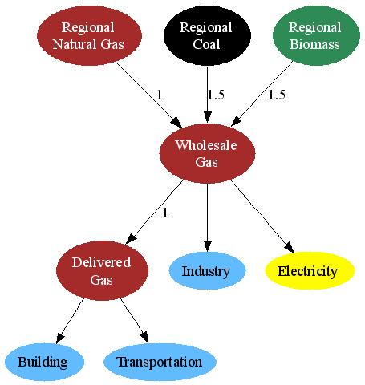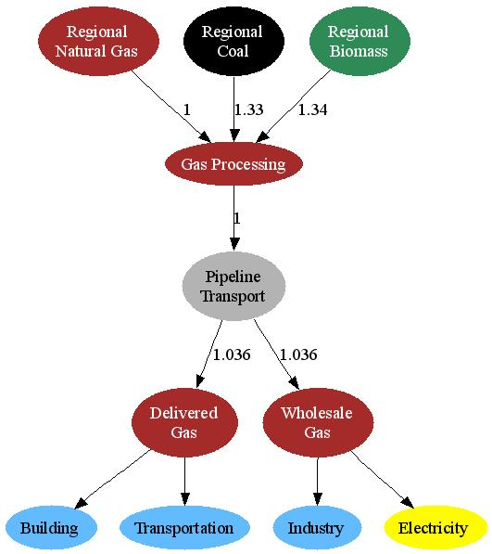
Figure 2. Old (left) and new (right) gas processing in MiniCAM. The numbers shown refer to input-output coefficients (the inverse of efficiency). The IO coefficients on pipeline transport are applicable only to the U.S.

The input-output coefficients and the non-energy costs of unconventional gas processing were also updated. The previous estimates of these technology parameters were pretty crude, and possibly as a result, no scenarios ever had production of gas from biomass or coal. The technology input-output coefficient for coal-to-gas is based on a proposed plant by Peabody Energy and ConocoPhilips, that would convert some 3.5 million tons of coal into about 60 billion cubic feet of natural gas (St. Louis Business Journal 2008). The IO coefficient for 2005 is shown in Figure 2; it is assumed to decrease at 0.05%/yr in the future. The cost of coal-to-gas is also informed by the cost estimates of this proposed plant, but is calculated as the assumed costs of a coal IGCC plant minus the capital and operating costs of a gas turbine. The resulting costs over time are shown in Table 1.
The biogas input-output coefficient is based on an analysis of biogas conversion efficiencies by a variety of techniques by Berglund and Borjesson (2008). The aggregate efficiency for MiniCAM was calculated as the average only among the sources modeled in MiniCAM: MSW, agricultural residues, and agricultural crops. Therefore conversion from sludge grease and animal waste by-products were not considered. Of the energy inputs to the conversions, only the heat and electricity energy inputs were considered, and electricity input was multiplied by 3, to represent a biomass-only conversion process. The other energy inputs (e.g. handling and transport of materials) are not considered in other energy sector conversion processes in MiniCAM and were therefore ignored. The IO coefficient (shown for 2005 in Figure 2) is decreased at 0.1% per year. All of these calculations may be revisited in the future if we include transportation-related energy requirements in the appropriate energy sectors.
Costs of bio-gas production are checked against costs estimated by the Government of Alberta (2006), but are calculated in similar fashion as coal-to-gas. The biomass IGCC costs are used, minus the costs of a gas combustion turbine. The resulting costs are shown in Table 1.

Table 1. Old and new gas processing non-energy costs in MiniCAM. All costs are represented in 1975$/GJ.
 | 2005 | 2020 | 2035 | 2050 | 2065 | 2080 | 2095
Previous: coal | 3.60 | 3.60 | 3.60 | 3.60 | 3.60 | 3.60 | 3.60
Previous: biomass | 3.60 | 3.60 | 3.60 | 3.60 | 3.60 | 3.60 | 3.60
New: coal | 2.99 | 2.95 | 2.63 | 2.41 | 2.20 | 2.10 | 2.09
New: biomass | 3.85 | 3.82 | 3.42 | 3.14 | 2.86 | 2.73 | 2.71

Costs and efficiencies of gas from natural gas feedstock have not been changed at this time. It isn’t clear how much of the costs of gas processing are already folded into the natural gas supply curves assumed in MiniCAM. Also, the input-output coefficient is difficult to determine, so it was decided to continue with the convention of effectively defining “regional natural gas” as gas downstream of the processing facility. The mining energy use is known, but it would be inconsistent to assess the mining energy for natural gas but not coal, oil, or any other fuels. The upgrading and processing energy is also known, and is substantial (the IO coefficient would be about 1.08), but secondary “natural gas liquids” fuels are produced and used by the refining sector, and it isn’t clear that there is any way to account for this while also keeping the model simple at the high levels. Therefore, an IO coefficient of 1 is assumed.
The pipeline energy use coefficient is calculated in each region as the total natural gas consumption in each region (“regional natural gas”) divided by that total minus the IEA’s pipeline energy use in that region. Many regions are assigned a 1 as the IEA does not have data on pipeline energy use, so there are no losses in either present or future periods. In all regions there is some gas assumed to be used upstream of the pipeline network—the gas consumed by the liquid fuel refining sector. This is (a) to keep the model as simple as possible at the high levels and avoid unnecessary simultaneities, and (b) because most of the gas consumed by “refining” in the future is for unconventional oil extraction and gas-to-liquids, both of which would take place presumably near a source of natural gas.
Non-energy costs are conserved from the previous model input for “delivered gas” (1.25 1975$/GJ) and are 0 for “wholesale gas”. Both of these are pass-through sectors with an IO coefficient of 1. The wholesale gas sector is conserved not only so that the sectors that demand gas would not have to have their energy inputs renamed, but also to allow for targeted pricing/policies applied to the industrial and electricity sectors apart from the buildings and transportation sectors.

2. Passenger and Freight Disaggregation
While the IEA transportation data by mode (i.e. air, rail, road, domestic ship, international ship) is not disaggregated into passenger and freight services, many countries within the MiniCAM regions maintain publicly available data on passenger and freight transport. Other organizations and researchers collect data; prominent among them are the OECD, the World Bank, and Lawrence Berkeley National Laboratory. In any case, the data souces are different for most of the countries, and are listed in the Appendix. An important methodological point to make up front is that the workbooks were set up with intensity “multipliers” that can be adjusted for future users to attempt to reconcile energy data with service data. These are not used in this round of the global transportation module. All multipliers are set to 1, so the intensities are the same as those calculated for the U.S. based on previous transportation work. The service output numbers from MiniCAM will therefore differ from national inventories. Again, the national inventories are only used at this time to disaggregate passenger from freight, assuming the same intensities as the U.S. region for transportation technologies.
All energy consumption by domestic ship is mapped to freight, and all energy consumption by international ship is kept separate, as international shipping is a separate final demand. All non-liquid fuel use by road (gas and electricity) is mapped to the passenger sector. The IEA categories that needed passenger/freight disaggregation were diesel rail, electric rail, coal rail (only applicable in China), road, and air. For a representative nation with data on passenger and freight service for any mode, the method of disaggregation is as follows:

The FreightService and PassengerService for the given mode come from data. The FreightIntensity and PassengerIntensity for the given mode are assumed equal to the U.S. (with the exception of passenger road, which is detailed in the following section). For multi-country MiniCAM regions (e.g. Western Europe), several representative countries with available data are used as a proxy for the entire region, with the energy fractions for the region calculated as the energy-weighted averages between the countries in the sample.
Data were collected for 24 countries to represent the 14 MiniCAM regions. For many countries/modes, the FreightEnergyFraction and PassengerEnergyFraction were assigned exogenously to return approximately correct values for one of the two types of service, if the other wasn’t known. For instance many nations have data on freight air travel in a World Bank report, but few have data on passenger air travel in terms of passenger km. Many other values were calculated from less direct sources, and are detailed in the Appendix. The disaggregation by mode and region is presented in Table 2.

Table 2. Freight and passenger energy fractions assigned to MiniCAM regions and transportation modes, assumed for both calibration periods (1990 and 2005). Note that the IEA does not have data on rail energy use in the Middle East, so no fractions were assigned.
region | mode | Freight Fraction | Passenger Fraction
USA | Diesel rail | 97% | 3%
USA | Electric rail | 0% | 100%
USA | Road | 21% | 79%
USA | Air | 15% | 85%
Canada | Diesel rail | 98% | 2%
Canada | Electric rail | 0% | 100%
Canada | Road | 29% | 71%
Canada | Air | 5% | 95%
Western Europe | Diesel rail | 95% | 5%
Western Europe | Electric rail | 5% | 96%
Western Europe | Road | 29% | 71%
Western Europe | Air | 11% | 89%
Japan | Diesel rail | 100% | 0%
Japan | Electric rail | 0% | 100%
Japan | Road | 29% | 71%
Japan | Air | 5% | 95%
Australia_NZ | Diesel rail | 95% | 5%
Australia_NZ | Electric rail | 13% | 87%
Australia_NZ | Road | 38% | 62%
Australia_NZ | Air | 5% | 95%
Former Soviet Union | Diesel rail | 89% | 11%
Former Soviet Union | Electric rail | 10% | 90%
Former Soviet Union | Road | 34% | 66%
Former Soviet Union | Air | 13% | 87%
China | Coal rail | 80% | 20%
China | Diesel rail | 80% | 20%
China | Electric rail | 15% | 85%
China | Road | 57% | 43%
China | Air | 15% | 85%
Middle East | Diesel rail | 0% | 0%
Middle East | Electric rail | 0% | 0%
Middle East | Road | 25% | 75%
Middle East | Air | 15% | 85%
Africa | Diesel rail | 33% | 67%
Africa | Electric rail | 17% | 83%
Africa | Road | 27% | 73%
Africa | Air | 5% | 95%
Latin America | Diesel rail | 83% | 18%
Latin America | Electric rail | 0% | 100%
Latin America | Road | 49% | 51%
Latin America | Air | 14% | 87%
Southeast Asia | Diesel rail | 10% | 90%
Southeast Asia | Electric rail | 0% | 100%
Southeast Asia | Road | 13% | 87%
Southeast Asia | Air | 8% | 92%
Eastern Europe | Diesel rail | 81% | 19%
Eastern Europe | Electric rail | 5% | 95%
Eastern Europe | Road | 30% | 70%
Eastern Europe | Air | 3% | 97%
Korea | Diesel rail | 20% | 80%
Korea | Electric rail | 0% | 100%
Korea | Road | 20% | 80%
Korea | Air | 20% | 80%
India | Diesel rail | 30% | 70%
India | Electric rail | 10% | 90%
India | Road | 20% | 80%
India | Air | 15% | 85%

3. Bus and light-duty vehicle (LDV) Disaggregation
Due to the highly variable fraction of road passenger transportation service supplied by bus across all MiniCAM regions, and the consequent implications for the meaning of “road” service intensity, bus and LDV transport energy and service are disaggregated. For instance, in India it is estimated that about 75% of passenger road service is supplied by bus, in contrast to less than 3% in the U.S. Therefore, if these were not disaggregated, any estimate of future road transport intensity decrease or increase would implicity include some exogenous estimate of how this LDV:bus share might change in the future. However this type of modal shift is the purpose of doing detailed transportation modeling.
The fractions of transit assigned to the different modes are shown in Table 3. Data sources are presented in the Appendix. The vehicle intensities of these two road modes are assumed equal to the US. In the current version, the load factors are also set equal to the U.S., so the effect is that service intensities of the different modes are equal in all regions. This representation therefore over-estimates the service intensity for most if not all other regions. For instance, Ji et al. (2008) estimate that bus transit in India is about 200 BTU/pass-km, whereas in the U.S. it is about 800. Future users will probably want to adjust the load factors in order to account for these types of differences in service intensities. While service intensities are likely to vary more significantly due to variations in vehicle load factors, we feel that vehicle intensities (BTU/veh-km) should be similar across regions. The consistent treatment of vehicle intensities is necessary for exploring the impact of new vehicle technology deployment in the MiniCAM. At this point we would caution against adjusting the vehicle intensities, in order to remain consistent with all other MiniCAM sectors, where future technologies have similar characteristics across all regions.

Table 3. Fraction of road passenger miles supplied by bus and LDV, by MiniCAM region. Note that this table splits the modes by service (in contrast to Table 2, for instance). Energy splits differ from the numbers shown as the intensities of the two modes differ.
 | Bus | LDV
USA | 2.8% | 97.2%
Canada | 4.5% | 95.5%
Western Europe | 8.9% | 91.1%
Japan | 10.2% | 89.8%
Australia_NZ | 10.9% | 89.1%
Former Soviet Union | 4.8% | 95.2%
China | 45.9% | 54.1%
Middle East | 6.5% | 93.5%
Africa | 19.8% | 80.2%
Latin America | 26.3% | 73.7%
Southeast Asia | 82.6% | 17.4%
Eastern Europe | 17.5% | 82.5%
Korea | 22.6% | 77.4%
India | 75.5% | 24.5%

4. Disaggregation of electric passenger rail into high-speed and conventional
High-speed rail systems currently exist in three MiniCAM regions: Western Europe, Japan, and Korea. While there is some difference in the passenger transportation intensity of high-speed rail, the real reason for this disaggregation is the different speeds of the two modes. If high-speed rail is kept with all other electric passenger rail, with an average speed of about 40km/hr, then we find that over time, rail becomes less and less used, due to the increasing time value of transportation as incomes increase. However, the opposite is likely true, particularly in the developed world, where transportation corridors are becoming increasingly congested and high-speed rail may be quite important for transportation in the future. This mode appears especially important in a future with a climate policy, as it may offer a low-cost opportunity to electrify a portion of passenger transport.
As with the detailed U.S. module, the assumed transportation intensities, load factors, and speeds are based on a report by CCAP & CNT (2006), which presented a survey of four existing systems worldwide: the Shinkansen, the Mag-LEV (both Japan), the TGV (France), and the ICE (Germany). Our assumptions of intensities, load factors, and speeds are unweighted averages of these four systems, as it is unclear how the technology will evolve over time. As with all other transportation technologies, the same assumptions are applied to all regions. The base year energy consumption by the three regions with existing systems is calculated from what data was available; for Europe, detailed service data was available by year (e.g. Jaensch 2008), allowing energy to be backed out using the assumed efficiency in MiniCAM. For Japan and Korea, service was inferred from the number of passenger trips each year (Ishida 2005; Campos and de Rus 2009), assuming an average transit distance of 75 km. This produced the following estimates of service output and energy consumption by these three regions (Table 4).

Table 4. Assumed energy consumption, service intensity, and passenger service by high-speed rail in existing systems in 2005.
 | Energy | Intensity | Service
 | EJ | BTU/pass-km | million pass-km
Western Europe | 0.0307 | 366 | 79400
Japan | 0.0081 | 366 | 21079
Korea | 0.0012 | 366 | 3000

This amounted to 13%, 12%, and 16% of total passenger rail electricity use by these three regions in 2005.

5. Non-CO₂ greenhouse gases
No additional research has been done on non-CO2 greenhouse gas emissions by the different components of the transportation modes that are now broken out (e.g. bus vs. LDV, freight vs. passenger). Therefore we assume the same non-CO2 GHG emissions coefficients, MAC curves, and control function parameters as in the aggregate version, for each technology that fits within the corresponding aggregate transportation technology. The mapping is shown in Table 5.

Table 5. Mapping of non-CO₂ greenhouse gas emissions coefficients from the detailed transportation to the aggregate transportation sector that was used in the RCP process, both for accounting of base year GHG emissions and in designing scenarios of future non-CO₂ greenhouse gas emissions.
Detailed | Aggregate
Freight air | air
Freight rail | rail
Freight road | road
Freight domestic ship | domestic ship
International ship | international ship
Passenger air | air
Passenger rail | rail
Passenger LDV | road
Passenger bus | road

Because the base year energy consumption by aggregate category (e.g. total road) is equal between the two representations, the non-CO2 greenhouse gas emissions are also equal for the base years. This does not guarantee identical scenarios going forward however, as the modal shifting differs between the two representations. However, within any mode, the control function parameters are identical between the two representations, so the emissions coefficients in any period are identical between the two represnetations.

6. Adjustments related to specific issues
This part is an ongoing process, and the representation as it stands now will not be long for this world. Such changes in the future need not be documented here. However, several issues came up immediately that will always have to be dealt with in any representation of global transportation, and are therefore noted.
- U.S. passenger transport demand. Even in the base year, the U.S. has high passenger transportation demands, and given our assumptions of average transit speeds of the different modes, the U.S. is already at about 1.5 hours per person per day. This is the approximate upper limit in Shafer (1998). In spite of the relative growth in high-speed modes in the future, the hours in transit nevertheless grows to about 2.5 hours per day by 2095 when income elasticity and price elasticity are 1. Therefore, an income elasticity of 0.8 is assumed (all other regions are 1), and the hours per day remains below 2.
- Southeast Asia air. A large portion of international aviation energy use is being attributed to the Southeast Asia region. Singapore especially is a major hub for international aviation and accounts for about 16% of total aviation energy use in Southeast Asia, but much of this travel does not involve people in Southeast Asia. Southeast Asia has the highest calibration value of all regions for the passenger air mode, and as a result, when income elasticity is 1, the total passenger km travelled grows very fast and by 2095 Southeast Asia has the most passenger travel of all MiniCAM regions. Therefore, passenger transport is given an income elasticity of 0.8 (it is 1 for all other regions, except for the U.S.), and the shareweight is dropped from about 0.05 in 2005 to 0.04 in 2095 (still among the highest in the world). This may or may not be a permanent solution, but in any case, future users should be aware of the issue. Moving Taiwan (another 13% of total SE Asia aviation) to China may alleviate this problem, but will probably not get rid of it.

Model Output
This section presents some output from the new detailed transportation module, for exploration into how and where it differs from the existing, aggregate module. Figure 3 shows global fuel consumption by transportation, with and without a policy, in the aggregate and detailed versions. As shown, the detailed version has slightly less responsiveness to a climate policy, due to relatively higher growth in aviation (driven by the increasing value of time) and the limited technology switching opportunities in the freight road subsector.

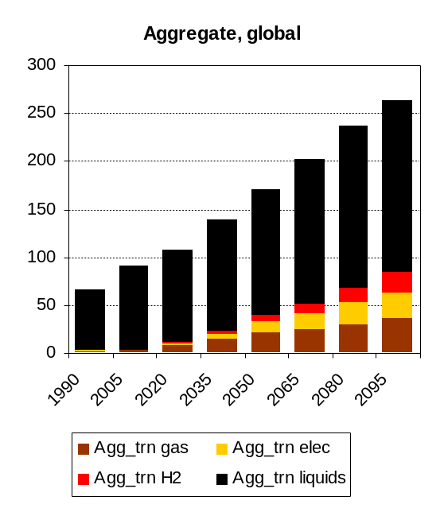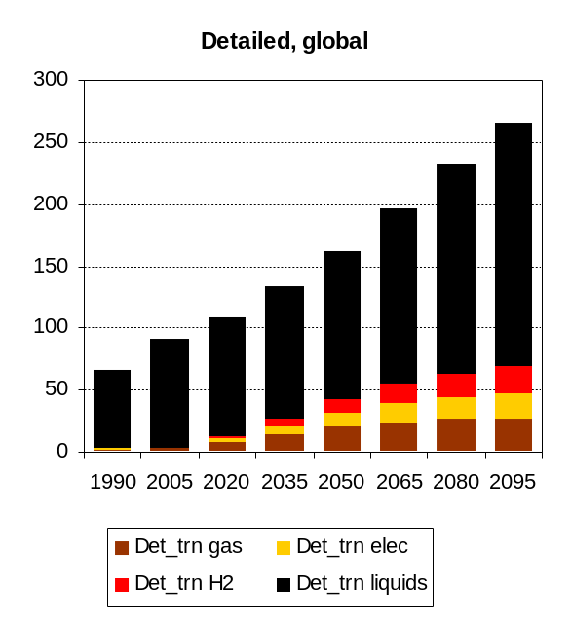
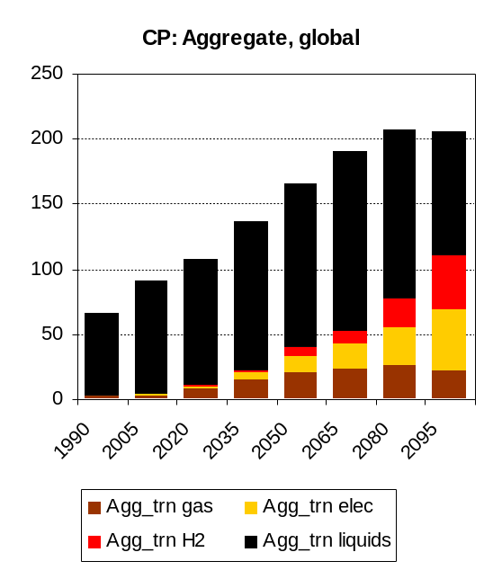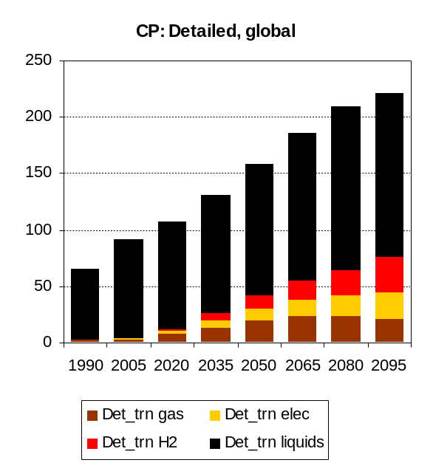
Figure 3. Global fuel consumption by transportation, fuel type, and scenario. CP = climate policy. The tax is $15/tC (1990$, equal to $5.65 per ton CO2 in 2005$) starting in 2020 and increasing at 5% per year.

Transportation fuel consumption by mode without a policy is shown in Figure 4.
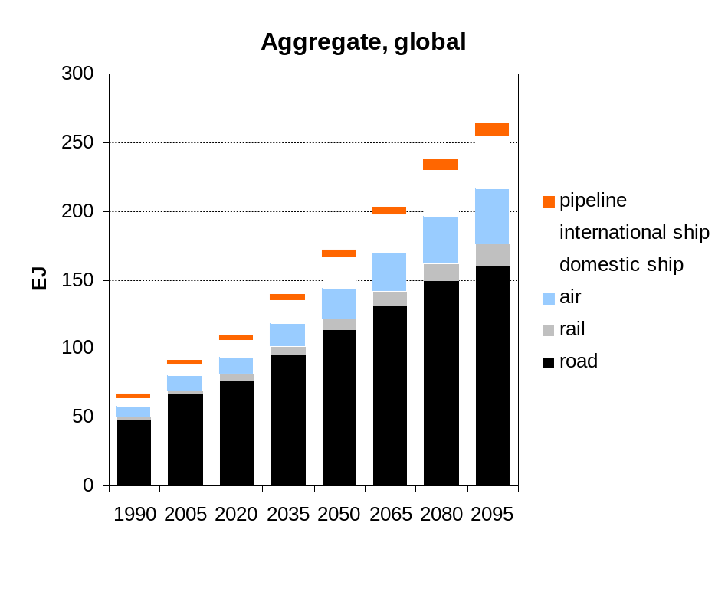
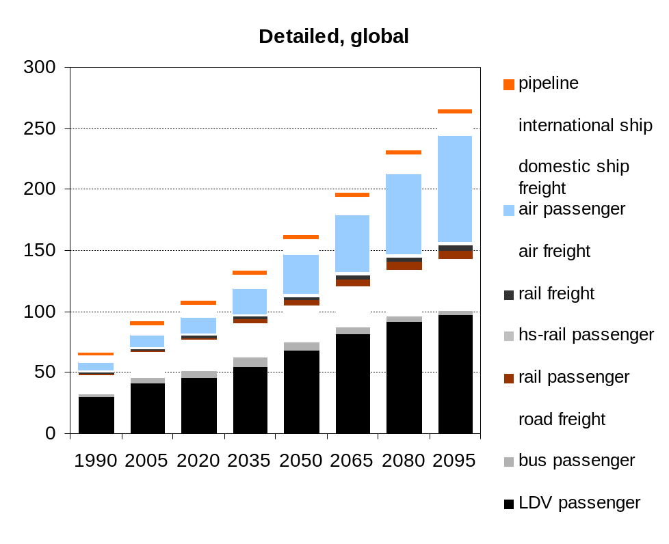
Figure 4. Total final energy consumption by mode, aggregate and detailed transportation sectors, with no policy.

As shown, the modal shifting going forward is different—the detailed version shows more shifting towards aviation over time, driven by the increasing value of time going forward. As well, pipeline energy use is lower, as it is now driven by the actual amount of natural gas demanded, and does not grow with the overall transportation service. Moreover it cannot substitute for other transportation technologies (e.g. air, rail) in movement of people/goods.
Finally, the non-CO₂ greenhouse gas emissions are shown in Figure 5. The most important part is that base year inventories match; of secondary importance is that the future scenarios are roughly consistent, as the emissions from the aggregate representation were used in the RCP scenarios, and again, the new detailed global transportation representation does not represent an advancement in research on non-CO2 GHG emissions. However, in the future, users could use the detailed representation to model the impact of catalytic converters applied to light duty vehicles but not freight trucks and buses, for instance. The detailed representation does expand the number of research questions that can be addressed with MiniCAM.
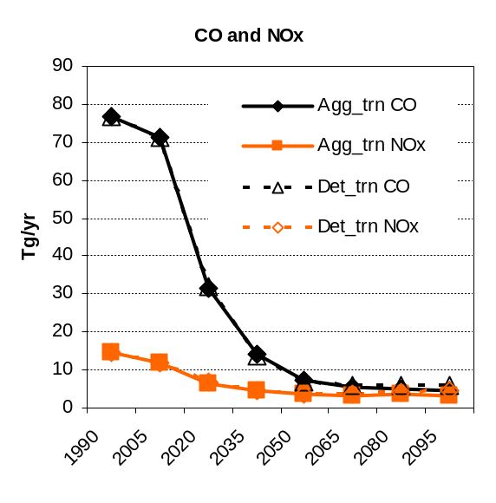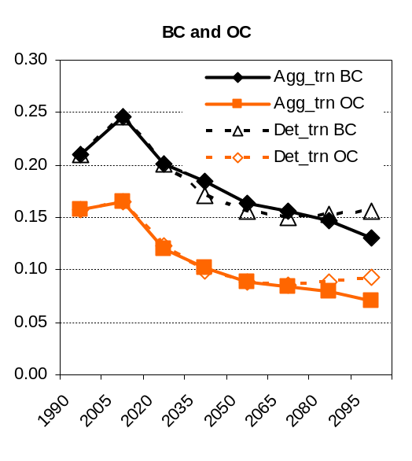
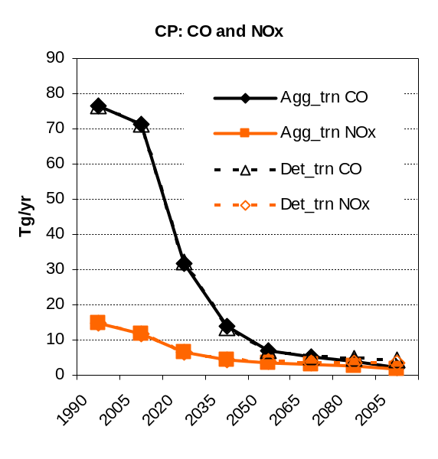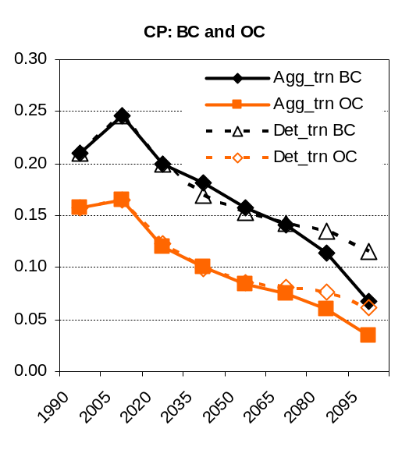
Figure 5. Emissions of CO, NOx, BC, and OC from the US transportation sector, with and without a climate policy (CP).

Appendix
This section presents the different data sources used in building up the service inventories by nation.

USA
The Transportation Energy Data Book (Davis and Diegel 2009) is used for all service data and technology efficiencies. The present representation links to the aggregated data pulled together for the detailed US module used from 2007 to 2009. Documentation can be found in Kyle et al. (2007).

Canada
- Passenger road, passenger rail, freight road, freight rail, and bus/LDV: VTPI (2007)
- Freight air: World Bank (2006)

Western Europe: France, Germany, Spain, and the United Kingdom
- Passenger road, passenger rail, freight road, and freight rail: VTPI (2007)
- Freight air: World Bank (2006)
- High Speed Rail: Jaensch (2008), Campos and de Rus 2009
- Bus/LDV: VTPI (2007)

Japan
- Passenger road, passenger rail, freight road, freight rail, passenger aviation, and freight aviation: Japan (2009)
- High Speed Rail: Ishida (2005), Campos and de Rus 2009
- Bus/LDV: VTPI (2007)

Australia_NZ
- Passenger road, passenger rail, freight road, freight rail, passenger air, and bus/LDV: Australian Government (2008)

Former Soviet Union: Russia
- Passenger rail, freight rail, passenger road, freight road, and bus/LDV: Dzedzichek (2007; AIM model).

China
- Passenger road, passenger rail, freight road, freight rail, passenger air, and bus/LDV: LBNL (2007).

Middle East
The data for this region is rare, and what does exist is of low quality. Even the IEA doesn’t even have data on rail energy use for any single country. Therefore it is assumed that 25% of road energy is for freight, and 15% of air energy is for freight.
- Bus/LDV: ESCWA (2008).

Africa: Egypt, Nigeria, and South Africa
- Freight road and freight rail: NationMaster (2008).
- Freight air: World Bank (2006)

Africa: South Africa
- Freight road and passenger road: derived from national data on vehicle km per day, Table 2.3.10 in South Africa (2001).
- Bus/LDV: Table 3.1.6 in South Africa (2001).

Latin America: Brazil
- Freight rail: NationMaster (2008)
- Passenger rail: several sources that are no longer available on the internet. The following websites are bookmarked: http://www.brazilintl.com/agbusiness/general/RailIndustryBrazil.pdf and http://www.eds-destatis.de/en/publ/download/lp_brazil.pdf
- Passenger road, and bus/LDV: Brazil Economy & Energy (1997).
- Freight road: calculated from freight rail based on World Bank (2009a).
- Freight air: World Bank (2006)

Latin America: Mexico
- Freight rail: OECD Infrastructure to 2030 report,
- Freight road: VTPI (2007), NationMaster (2008), World Bank (2006), and North America Transport Statistics (2008). (all estimates were similar)
- Passenger rail: OECD Infrastructure to 2030, also calculated from freight rail using same fraction as North America Transport Statistics (2008).
- Passenger road: NationMaster (2008)
- Freight air: World Bank (2006)
- Passenger air: North America Transport Statistics (2008).

Southeast Asia: Indonesia
- Passenger rail and freight rail: NationMaster (2008)
- Freight air: World Bank (2006)
- Passenger road and freight road: estimated from rail service based on World Bank (2009b).

Southeast Asia: Pakistan
- Passenger rail, freight rail, passenger road, freight road: NationMaster (2008). Road estimates adjusted to common base year by fuel consumption.
- Freight air: World Bank (2006)

Southeast Asia: Thailand
- Passenger rail, freight rail: NationMaster (2008).
- Freight air: World Bank (2006)
- Passenger road and freight road: estimated from rail service based on Thailand Development Research Institute (2003).
- Bus/LDV: Thailand Development Research Institute (2003).

Eastern Europe: Czech Republic, Hungary, and Poland
- Passenger road, passenger rail, freight road, freight rail, and bus and LDV: VTPI (2007)
- Freight air: World Bank (2006)

Korea
- Passenger rail, passenger air, and freight air: KOSIS (2006).
- Freight rail, passenger road, and freight road: Korean Ministry of Construction and Transport (2006).
- High-speed rail: Campos and de Rus 2009
- Bus/LDV: VTPI (2006).

India
- Passenger rail and freight rail: NationMaster (2008).
- Passenger road and passenger air: Han et al. (2008).
- Freight road and Bus/LDV: Zhou (2007).
- Freight air: World Bank (2006).

References
Australian Government (2008). Australian Transport Statistics, Bureau of Infrastructure, Transport, and Regional Economics. http://www.bitre.gov.au/

Berglund and Borjesson (2008). Energy Analysis of Biogas Production. Lund Institute of Technology. http://www.lth.se/fileadmin/energiportalen/Filer/Om_Energiportalen/Invigning/Posters/Energy_analysis_of_biogas_production_Maria_Berglund_P_l_B_rjesson.pdf

Brazil Economy & Energy (1997). Evolution of the Vehicle Fleet in Brazil. http://ecen.com/eee16/ev_fleet.htm

CCAP & CNT – Center for Clean Air Policy and www.cnt.org/repository/HighSpeedRailEmissions.pdf

Davis and Diegel (2009). Transportation Energy Data Book, Oak Ridge National Laboratory. www-cta.ornl.gov/data/index.shtml

Dzedzichek, M. (2007). Russian residential and transportation sectors scenarios: coming to 2050. AIM training workshop. http://www-iam.nies.go.jp/aim/AIM_workshop/AIMtw07/Oct26th/5-3_participants_presentations/4_Presentation_Russia.pdf

ESCWA—United Nations Economic and Social Commission for Western Asia (2008). Middle East Vehicle Stocks. not sure of URL.

Government of Alberta (2006). Biogas (Methane) Overview. http://www1.agric.gov.ab.ca/$department/deptdocs.nsf/all/afi11109

Han, J. et al (2008). Evaluating policies for CO2 mitigation in India’s passenger transport. International Journal of Urban Studies 12(2): 28-39. http://ijus-uos.com/ijus/journal/download.php?filename=Ji%20Han.pdf&lnum=192

Ishida, Y. (2005). The Future of High-Speed Train. http://ieeexplore.ieee.org/stamp/stamp.jsp?arnumber=01452101

Jaensch, E. (2008). High-Speed Rail (HSR) in Europe. Presentation for Norsk Bane AS. www.norskbane.no/nb/seminar190608/DrJaensch.ppt

Japan (2009). Statistics Bureau Home Page. http://www.stat.go.jp/english/index/official/209.htm

Korean Ministry of Construction and Transport (2005). Handbook of Road Management 2005. Cited at http://www.greengrowth.org/download/GGPD_CD_resources_for_website/20_Chung%20Mo%20Koo.pdf

KOSIS—Korea Statistical Information Service (2006). http://www.kosis.kr/

Kyle et al. (2007). The Value of End-Use Energy Efficiency in Mitigation of U.S. Carbon Emissions. PNNL 17039. www.pnl.gov/main/publications/external/technical_reports/PNNL-17039.pdf

LBNL—Lawrence Berkeley National Laboratory (2004). China Energy Databook v.6.0. LBNL-55349. http://china.lbl.gov/databook

NationMaster (2008). Transportation Statistics. http://www.nationmaster.com/cat/tra-transportation

North America Transport Statistics (2008). http://nats.sct.gob.mx/nats/sys/themes.jsp?id=5&i=3

St. Louis Business Journal (2008). Peabody, ConocoPhillips choose site for Ky. plant. http://www.bizjournals.com/stlouis/stories/2008/12/15/daily25.html

Shafer, A. (1998). The global demand for Motorized Mobility. Transportation Research Part A 32(6): 455-477. http://www.sciencedirect.com/science?_ob=ArticleURL&_udi=B6VG7-3T88FM7-5&_user=961305&_rdoc=1&_fmt=&_orig=search&_sort=d&view=c&_acct=C000049425&_version=1&_urlVersion=0&_userid=961305&md5=9ea440d7d998536d3125708b8e5971e9

South Africa (2001). Report on transport statistics that seems to have been removed. Website used to be http://www.transport.gov.za/library/docs/stats/2001/statistics.html

Thailand Development Research Institute (1993). Strengths and Weaknesses of Railway Transport. http://www.tdri.or.th/library/quarterly/text/s93_4.htm

VTPI—Victoria Transport Policy Instutute (2007). OECD Country Data Summary. www.vtpi.org/OECD2006.xls

World Bank (2006). World Development Indicators 2006. http://books.google.com/books?id=gE7bCAqKkkUC&printsec=frontcover&dq=world+development+indicators&client=firefox-a#PPA294,M1

World Bank (2009a). Transportation Country Case Study: Brazil. http://go.worldbank.org/CZLPQYF6D0

World Bank (2009b). Transport in Indonesia. http://go.worldbank.org/PF2AFG64V0

Zhou, N. (2007). What do India’s Transport Energy Data Tell Us? LBNL, 2007 ECEEE Summer Study. www.eceee.org/conference_proceedings/eceee/2007/Panel_8/8.270/

